

**ISM 6217 – Database Management Systems**

**Fall 2017**

**Class Assignment 6**

**5 points**

**Task: Practicing Table Joins**

Execute this query to see all the tables you currently have in your Oracle database:

**SELECT table_name**

**FROM user_tables;**

Now query each table to look at the table data. Execute SQL’s (see lecture slides) to perform Table joins of the following types.

**Explain the reason for the join. Paste screen shot of the SQL and Results.**

1. **Cartesian Join** (1 point)
2. **Equality Join** (1 point)
3. **Non-Equality Join** (1 point)
4. **Self Join** (1 point)
5. **Outer Join** (1 point)
6. **Cartesian Join** (1 point) – each book can be clubbed with multiple gifts – the combination of each book with a promotion item is selected with the Cartesian join.

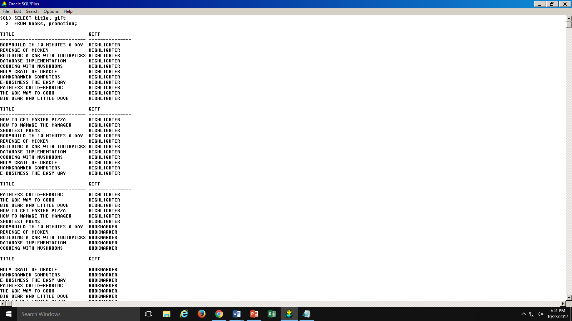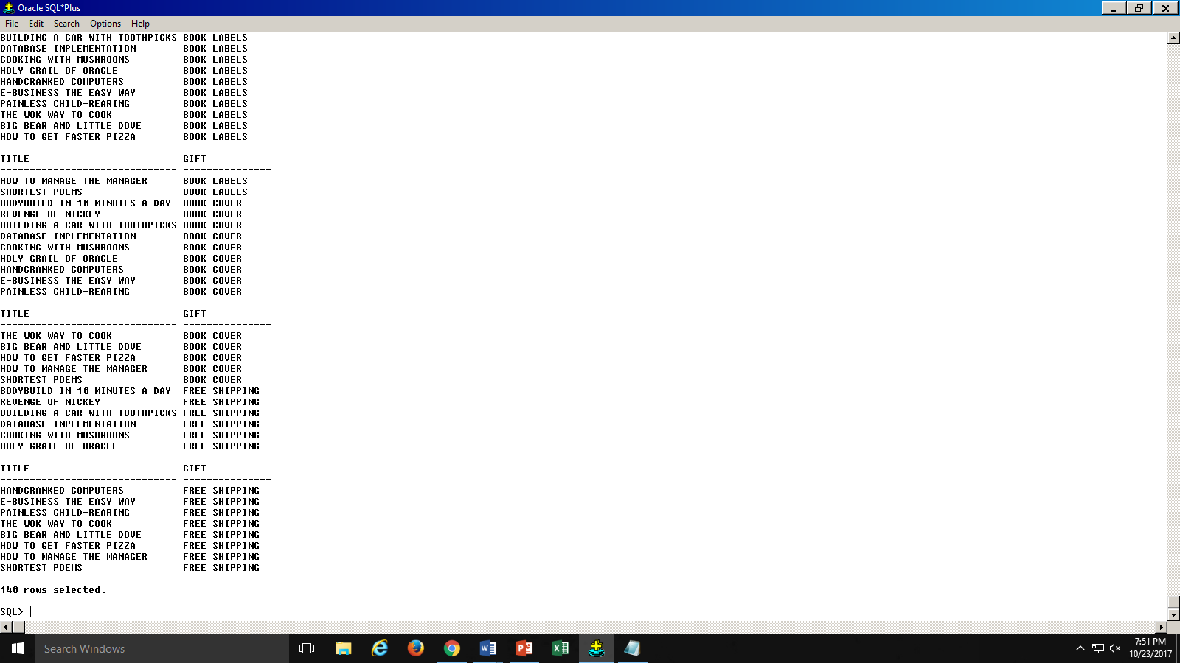

140 rows selected – 14 books* 10 gift items (updated in my SQL in last assignment) = 140 rows is CORRECT

1. **Equality Join** (1 point) –used to give the details of the cars under the the corresponding invoice no. (from project 2).

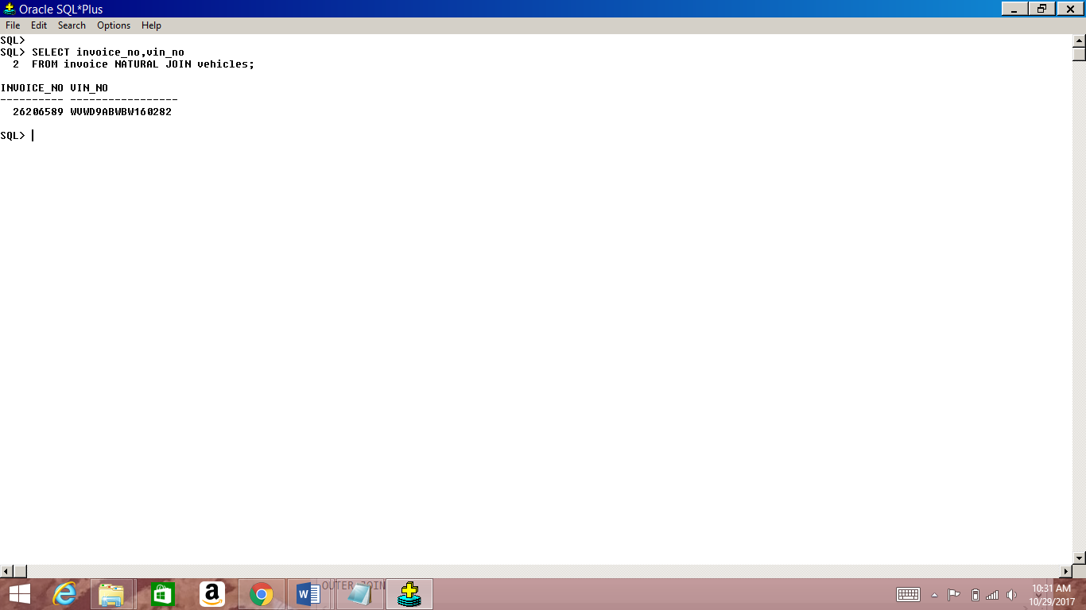

1. **Non-equality join** (1 point) – the following query is used to return the gifts that are eligible for each order#

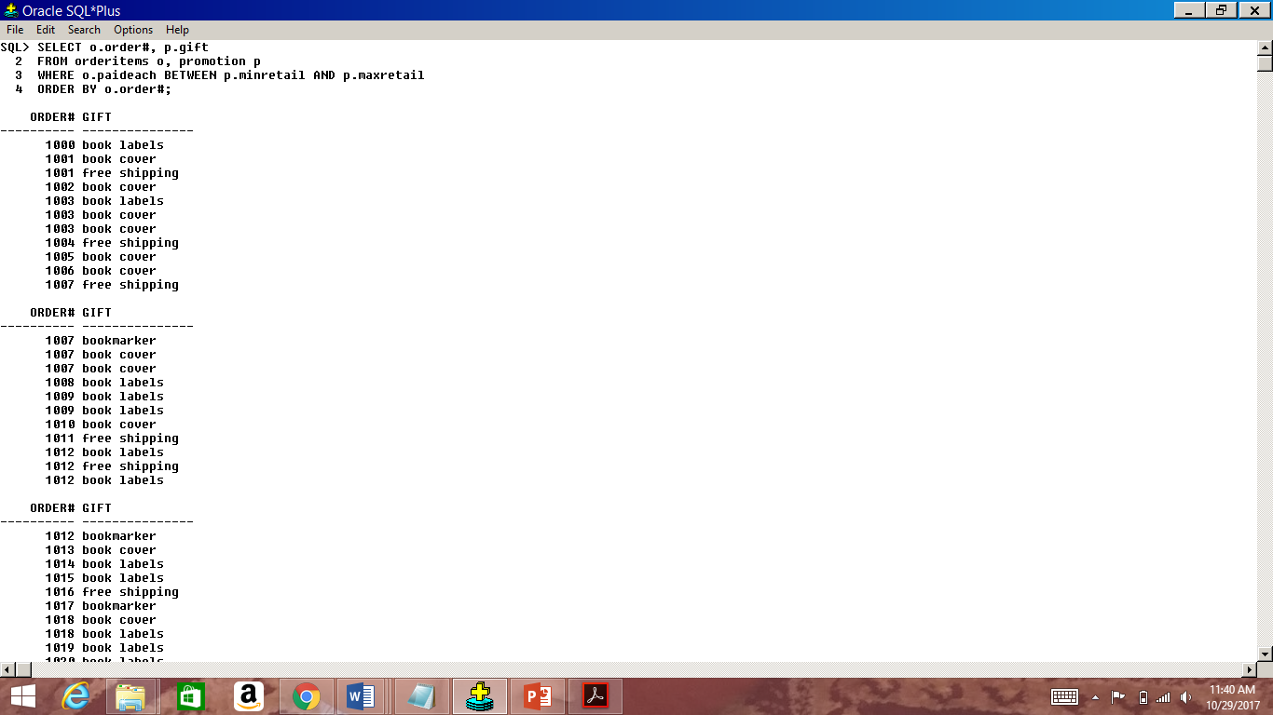

**32 rows selected- 1 gift for each order**

1. **Self Join** (1 point) – Selects which customer was referred by whom. Also shows at a glance how many a single customer referred to – if the company wants to give a gift/ promotion offer to customers for referring a certain number of customers.

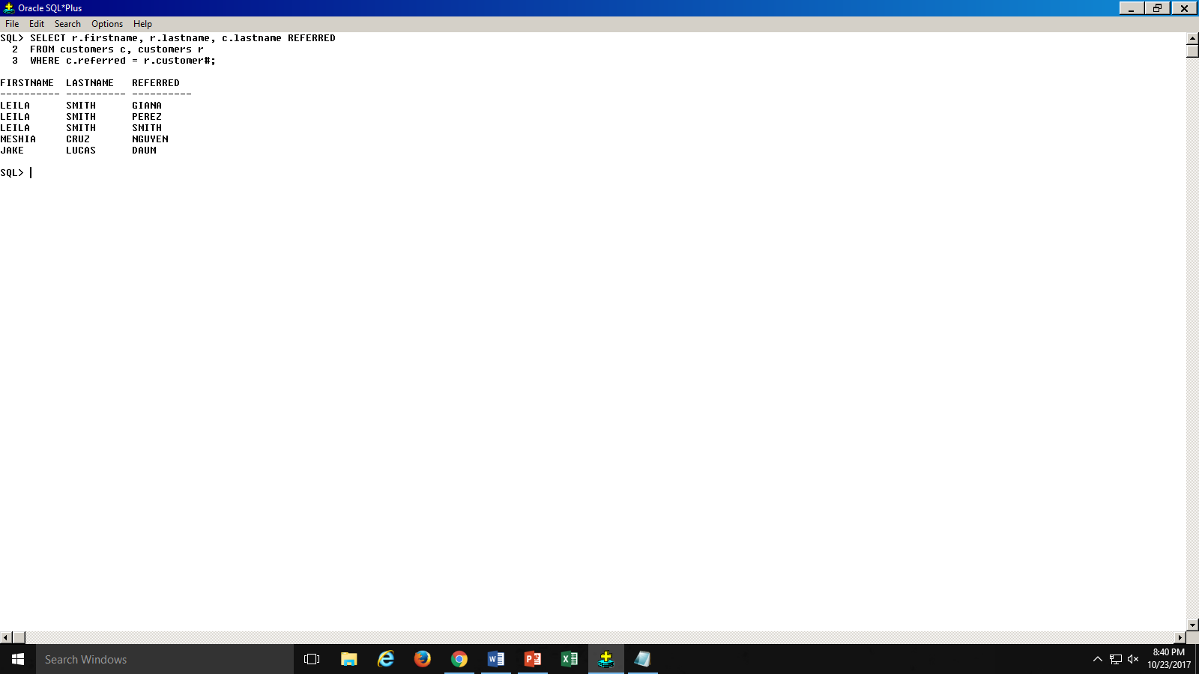

1. **Outer Join** (1 point) -– the Outer join is being used to understand which author’s book was not ordered at all and also which author;s book was ordered the most or which is the most popular author amongst JustLee’s customers. In this case an author’s book has not been ordered at all, the query should return null.

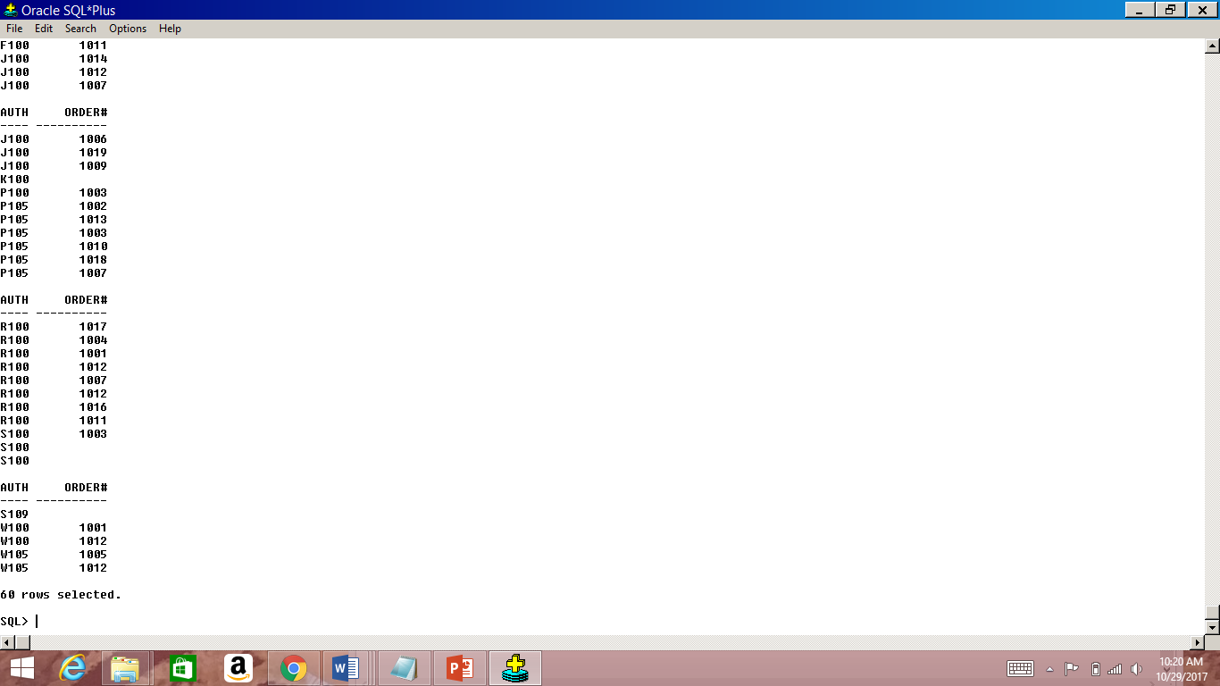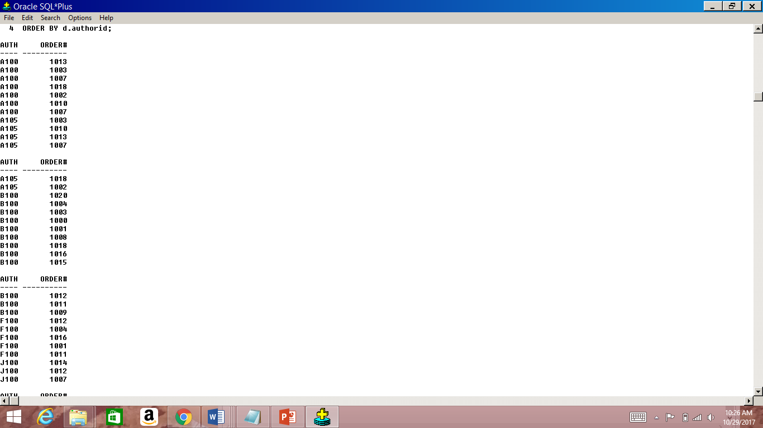

**So as can be seen from the above table, authorid S109 and K100 books are not ordered under any order# - returns null values.**